Arabia Submitted to the Coding Academy by Orange

By Sarah Hasan

March 2022

**Summary**

The goal of this web application is to learn Arabic for non-native speakers from anywhere in the world. This free platform provides the ability to access the site at any time and for anyone from anywhere, and start learning for each person according to his level. The site was built using the Laravel framework, which handles the file Database of storage for users, storage for courses, as well as user interface creation and control all displayed data and navigate between different user interface pages.

**ACKNOWLEDGMENTS**

I would like to express my deep sense of gratitude and convey thanks to everyone who helped me and supported during the completion of this project. I would like to express a deep sense of gratitude to my trainers: Mr.Salameh Yasin, Mrs. Ala'a Mohammed, Mr. Muhammed AlShawiki, and Ms. Khadejah Hamdan for helping, guiding, and supporting me throughout my journey to learn coding and for supporting me, and for allowing me to do something the way I liked, without them this project would have been impossible.

**TABLE OF CONTENTS**

Summery.............................................................................................1 Acknowledgments......................................................................................2 Introduction….......................................................................................3 User Interface...................................................................................... 4 Software Interface.................................................................................. 3 Courses Function................................................................................... 4 User Characteristics ............................................................................... 5 Wireframe.......................................................................................... 8 Mockup.............................................................................................. References........................................................................................ 3

**CHAPTER 1. INTRODUCTION**

Learn Arabic Online contains a large and evergrowing repository of tutorials on the Arabic language Here you can learn to read Arabic, write Arabic, learn Arabic numbers, learn Arabic verb conjugation, delve into Arabic grammar, and much more.

The material ranges from absolutely introductory Arabic lessons to short Arabic courses for even the most advanced literatures. Both the absolute basics of the language are covered, such as the Arabic alphabet and verb conjugation, as well as very advanced material, such as Arabic poetry and deep etymology. It is an extraordinary supplement to Arabic language courses and is an invaluable and authoritative resource for Classical Arabic.

How to Learn Arabic Fast and Free Online The complete study of classical Arabic involves several sciences, all of which are covered in our tutorials. Here you will find lessons and useful exercises that will improve your reading and lexicology, writing vocabulary and grammar .

We take a classical approach to Arabic that has been inspired by the Basran camp of grammar. As such, this website is primarily designed to acquaint you with classical, liturgical Arabic. So if you’re looking to learn Qur’anic Arabic online, then no matter what level you’re starting from, this website will take you from there. And God is the all-helping.

**2.1.1.1. user interface**

The three types of facades found in the green market are as follows: 1. User interface: Users can enter the site and learn the Arabic language for free through videos available for each course, and the user can choose the course that suits him and start learning directly through our platform. 3. Admin Control Panel: Administrator can view all users, also can delete them Them and manage categories and subcategories, keep track of all user commands.

**2.1.1.2. Software Interface**

This section lists the requirements that are needed to run the system efficacy are as follows:

1. Operating System: Windows (Windows 7 and above) or MAC OS 2.

2. Web Brower: Internet Explorer (8.0 and above), Mozilla Firefox (3.0 and above), or Google Chrome.

**2.1.2. Course Function**

The Green Market application would have the following basic functions: 1. Display all the categories available for learning on the system’s main page. 2. Display all the sub-categories available for learning on the system’s category page. 3. Display all the items linked to each subcategory listed on the category page. 4. Allow the administrator to view the information about each user.

**2.1.3. User properties**

Arabia app users according to their roles are Customers (Users) and Administrator (Owner). these Users are selected based on their expertise and technical expertise. 1. Administrator: The admin is the owner of the Arabia app. One must have a basic understanding of computers and the Internet. Responsible for maintaining all training documents System required. The administrator can perform the following functions: A. User management. B. Define categories and subcategories. 2. Users: Arabia app users are familiar with browsing the site. They must have basic understandings about Computers and the Internet. Users must be able to perform The following functions using this system: A. View, browse, and select a category on the home page. B. View, browse and select a subcategory on the category page. C. Play a video. D. Register / log in with your username and password.

**Arabia Wireframe**

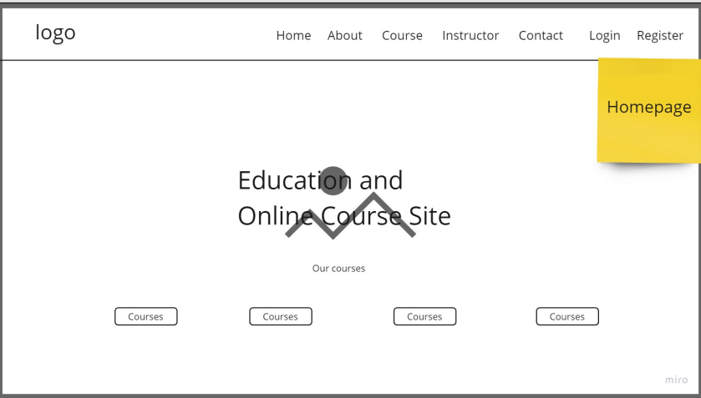

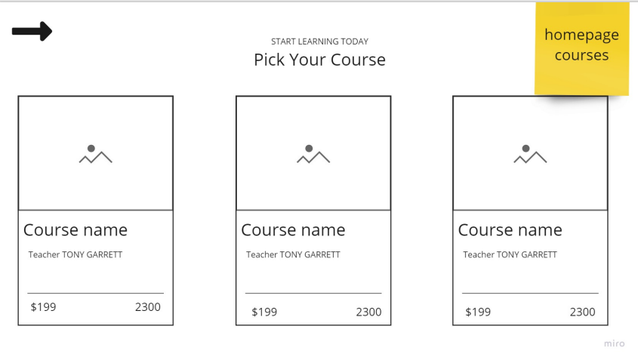

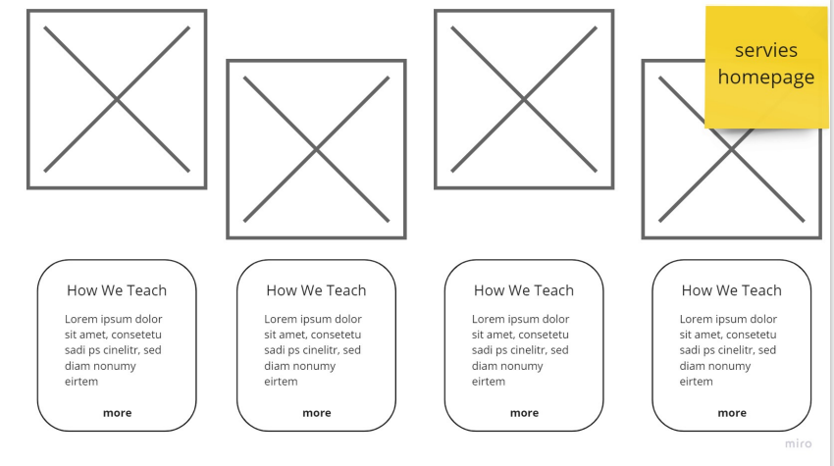



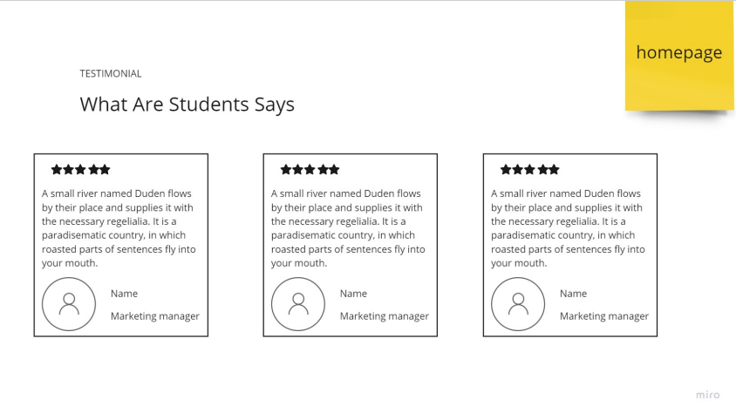

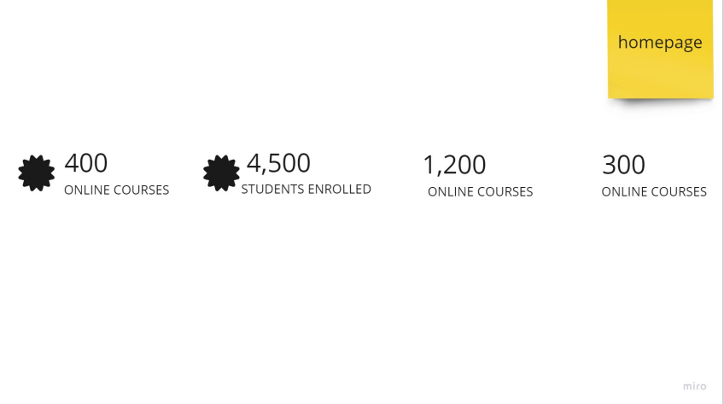

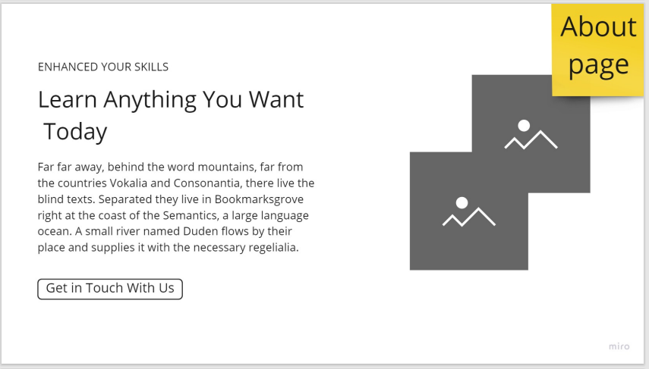

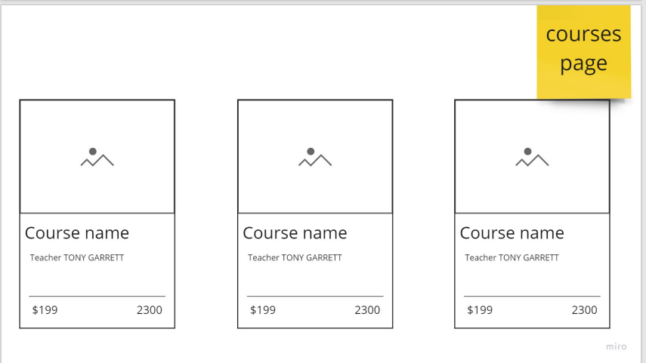

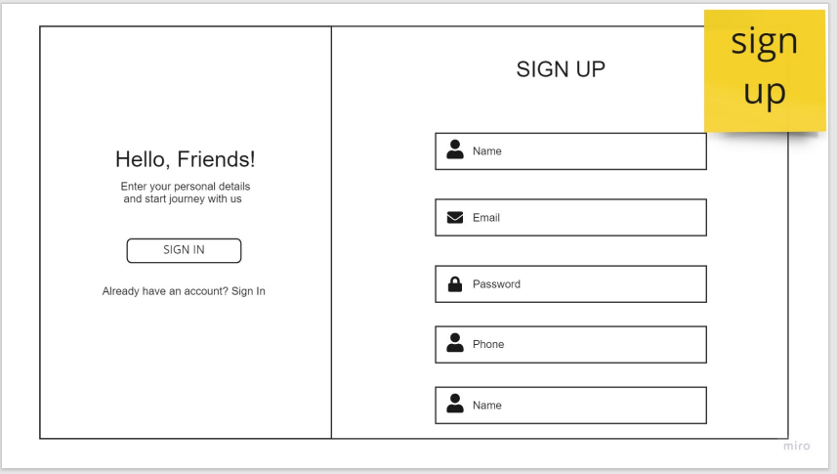

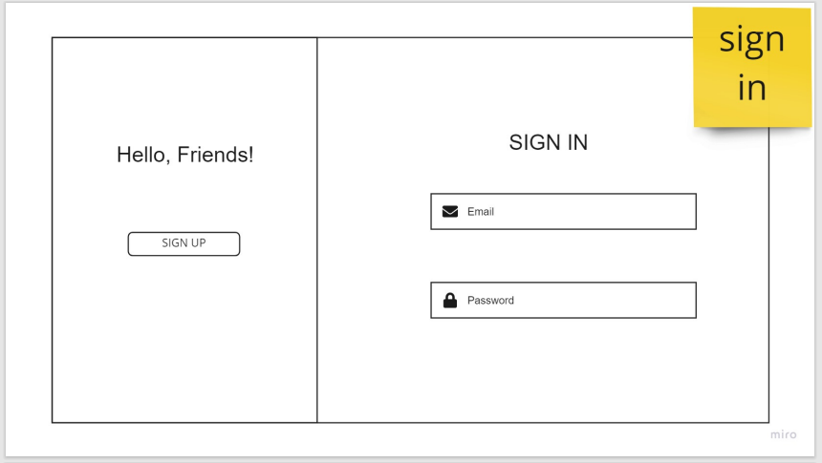

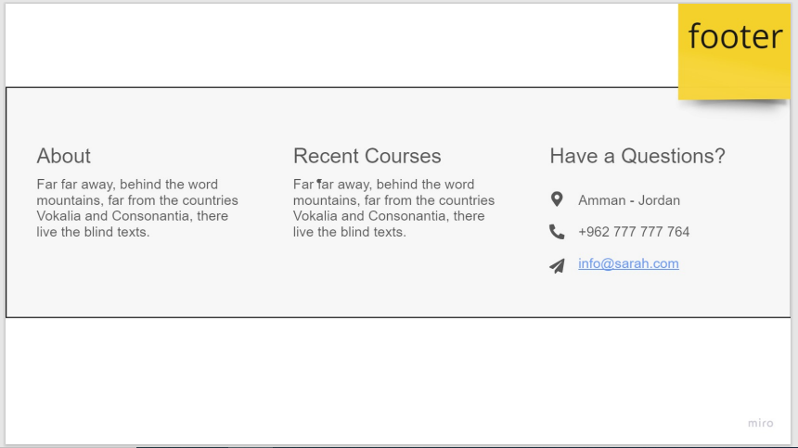

**Arabia Mok up**



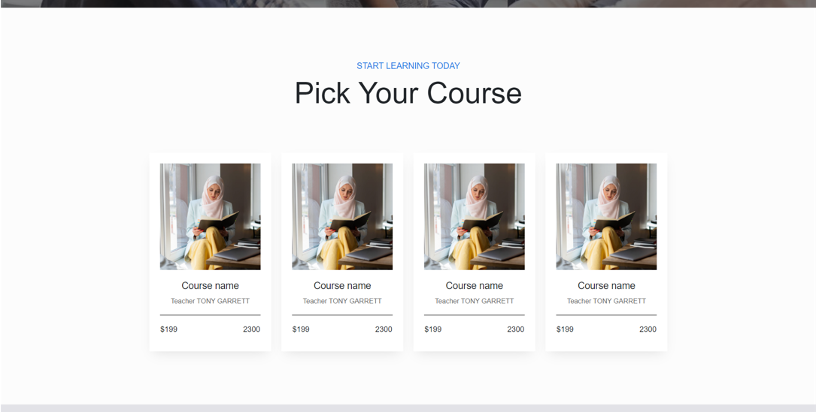

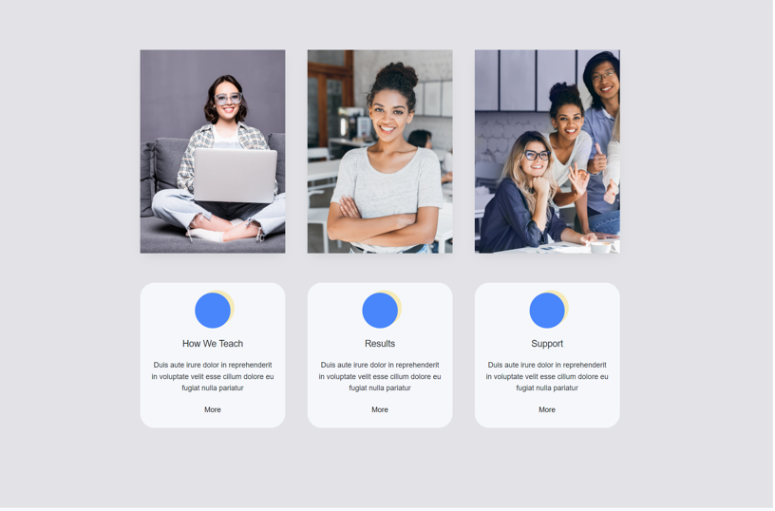

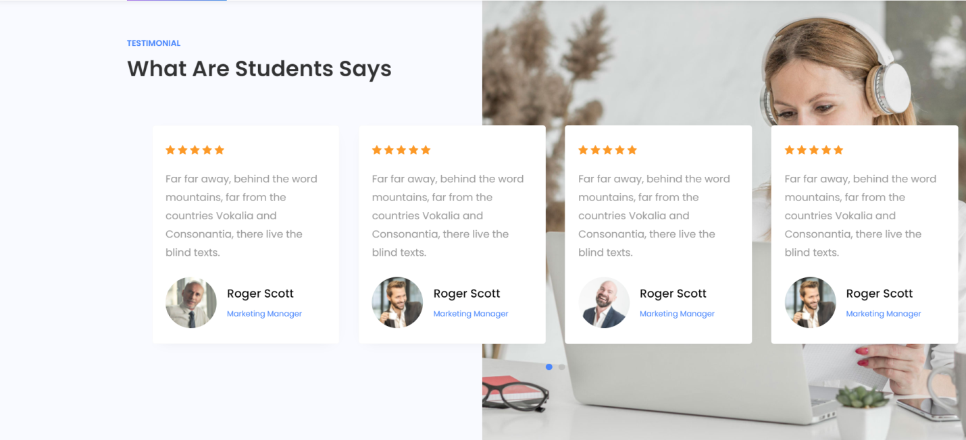

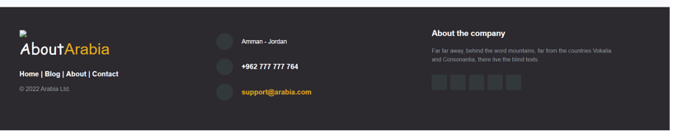

**About us Page**

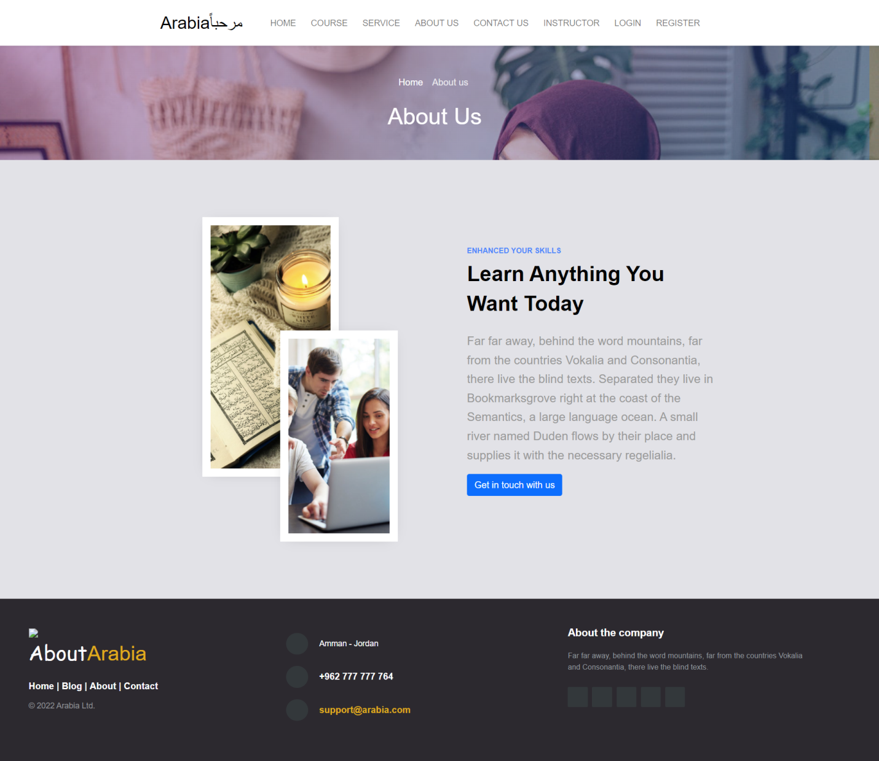

**Course Page**

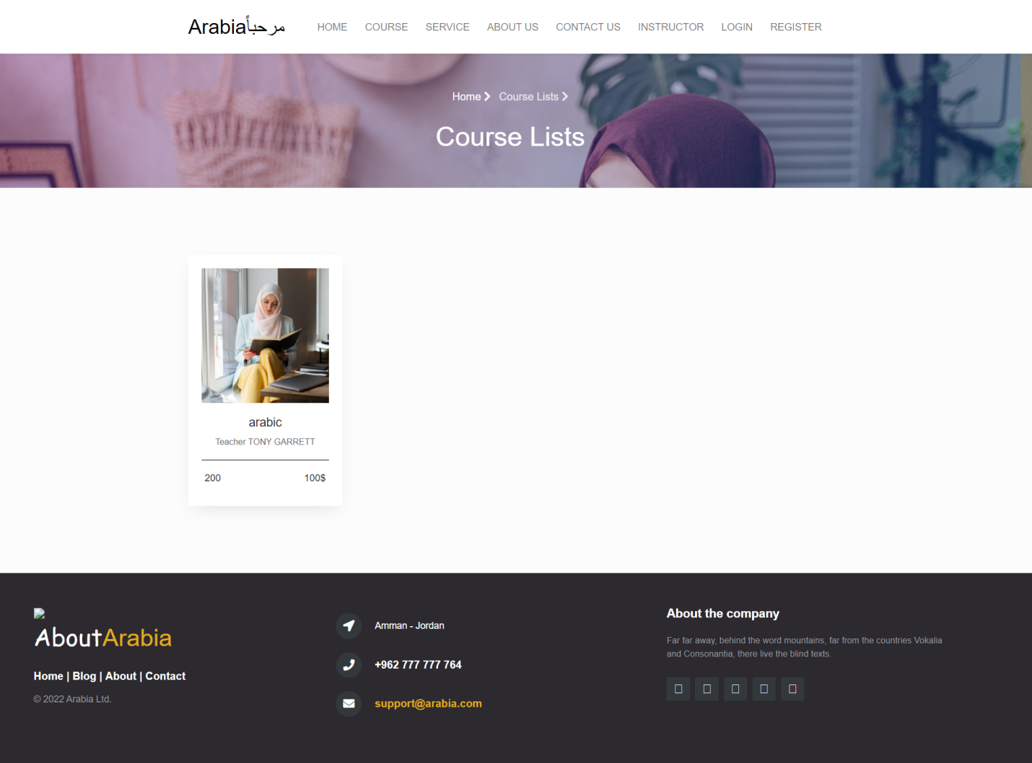

**Sign In**

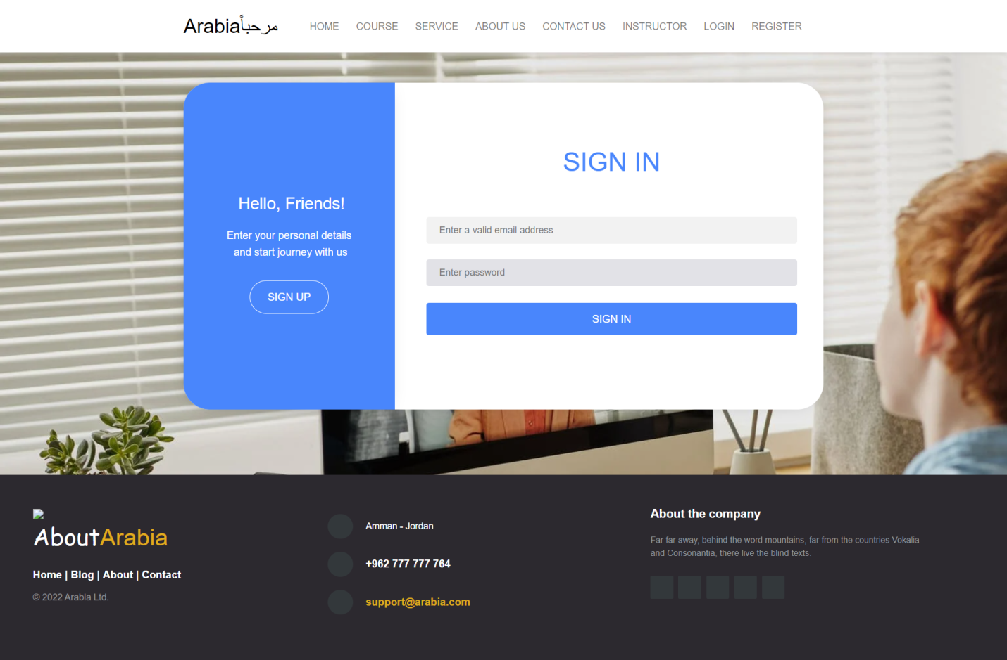

**Sign Up**

